## Introduction

Presented below is an analysis of our district’s data. The analysis begins with observations at a very high level and eventually narrows in on which schools (and what types of schools) are having the most success as well as which ones are struggling the most. We will focus predominantly on math and reading scores as a metric for school success.

## District Overview

Figure 1 shows a summary of data across our entire district. The vast majority of our students are passing either their reading or mathematics class. The Overall Passing rate (students who are passing both reading and mathematics) is slightly satisfactory but could stand to grow.

  
Figure 1. An overview of district wide data

Before diving into how to raise this overall passing percentage, it makes sense to look closer at individual school data to analyze what is working and what is not working within our school district.

## Per School Analysis

Figure 2 shows a breakdown of school enrollment, budget, and performance in reading and mathematics courses for each of the schools in our district. A quick scan shows that our charter schools are out-performing our normal district schools by a significant margin, particularly with respect to passing rates. (Average scores are also significantly higher, but what’s notable is that far less students are falling between the cracks at our charter schools).

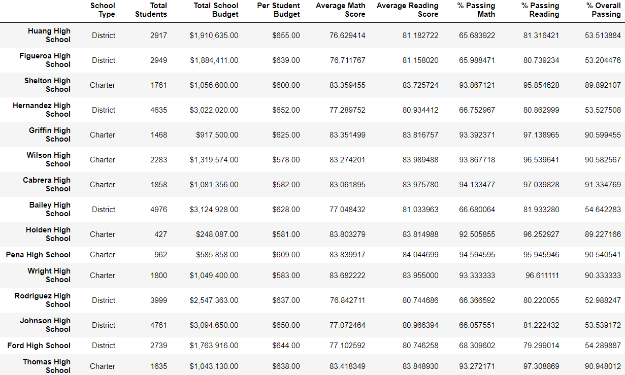  
Figure 2. A per school overview of how each of the schools in our district are performing

Figure 3 shows a snapshot of our top 5 performing schools. As a quick glance at Figure 2 might have suggested, the top performing schools are charter schools. Notice that several schools on the list have a per student budget of less than $600, which is easily on the less expensive end for our district.

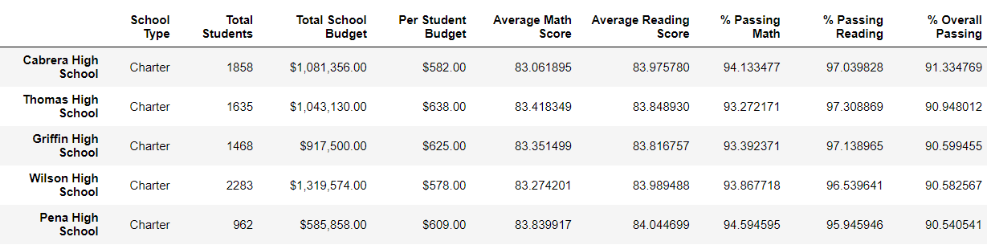Figure 3. A snapshot of the top performing schools in our district.

Figure 4 shows a snapshot of our bottom 5 performing schools. Notice that these schools are also on the most expensive end for our district, with the top 3 per student budget schools rounding out the end of our bottom 5.

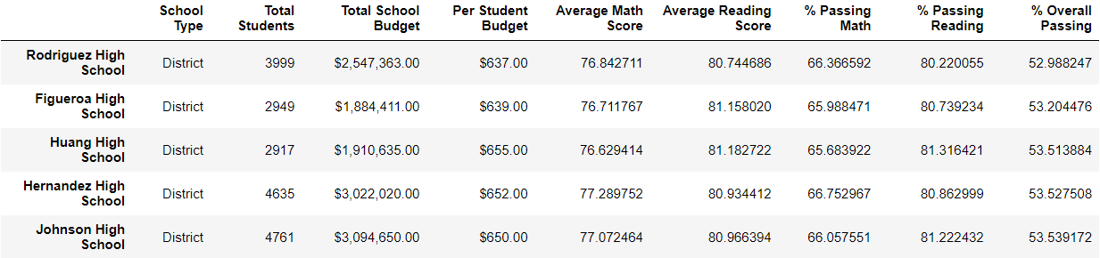  
Figure 4. A snapshot of the bottom performing schools in our district.

We can already see that charter schools are generally outperforming district schools in terms of passing rate, average grades, and use of budget. Let’s see how that trend holds across various grade levels at our high schools.

## Grade Level Analysis

Figures 5 and 6 on the next page give a breakdown of passing rates for math and reading at each school per grade level. A quick look shows that there isn’t much variance in passing rates across grade levels at any of the schools in our district.

(A school type analysis is included on the page following figures 5 and 6).

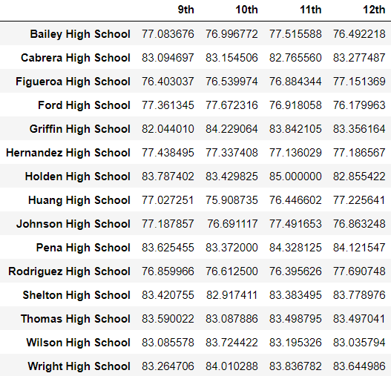  
Figure 5. Average math scores per grade level at each school in our district.

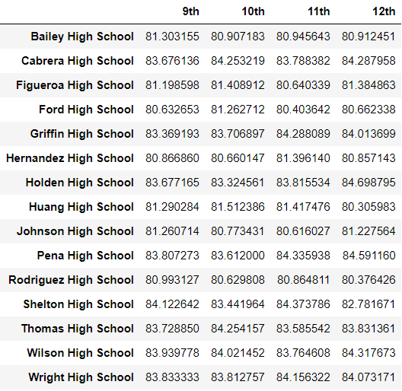  
Figure 6. Average reading scores per grade level at each school in our district.

## Scores by School Type

Figure 7 shows average scores and passing rates per school type. As foreshadowed by our top 5 and bottom 5 school performance snapshot, charter schools are outperforming other district schools by a significant margin in each metric measured.

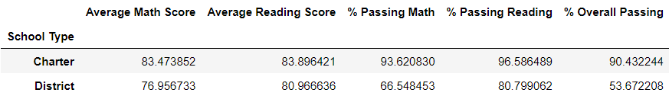  
Figure 7. Average scores and passing rates by school type.

## Summary of Analysis

It is overwhelmingly clear that charter schools are outperforming district schools by a significant margin. Our grade level analysis shows that the difference in student performance across grade levels per school is insignificant with respect to the difference in student performance across different schools or school types. The author recommends further study into what charter school processes are contributing to greater student success so that they can be implemented district wide.